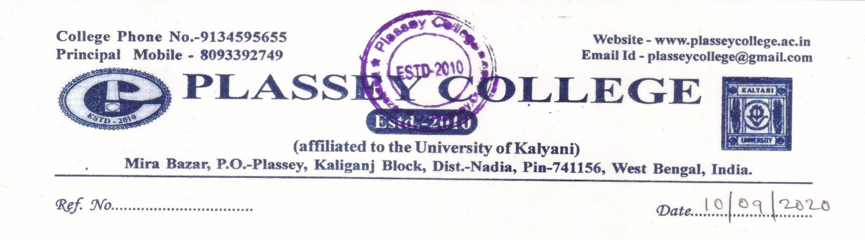

THE DETAILS OF SUSPENDED OFFICIALS AND STAFF OF PLASSEY COLLEGE
NAME OF THE SUSPENDED EMPLOYEE | NAME OF THE OFFICE/INSTITUTION WITH ADDRESS | SUSPENDED FROM | REASON FOR SUSPENSIONS | ANY OTHER DETAILS
NIL | PLASSEY COLLEGE MIRA BAZAR, PLASSEY, NADIA-741156 | NA | NA | NA

